Documentation

Name: N. Sri Vidya

Roll no:234355

Class:II BSC Computer Science2

Submitted To: Rajshekar sir

Submitted Form: N. Sri Vidya

The process: Github Django -docker container-dockerhub

1**.create a new folder:**

* *Go to file manager*
* Go to direct
* Create a new folder
* save it with a name

local disk(D):



**2.open gitbash and change directory to new folder:**

* Go to the file where did you save
* Change it to your folder name



**3.clone for git:**

It is used to copy the file which is already exits

Syntax

Git clone <https://github.com/rajasoxit/batch02-django-app.git>

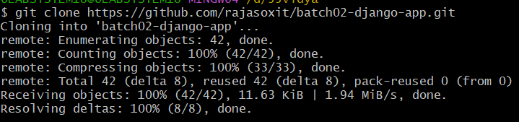**Example**

**4.change directory:**

**It is used to change directory**

** 5.Docker ps:**

* Ps means “process status”
* Docker ps command is used to list all the running containers in the docker host



**6.docker build:**

* It is used for build a image
* ‘,’ it is used to bring all file in the folder to build

**Example:**

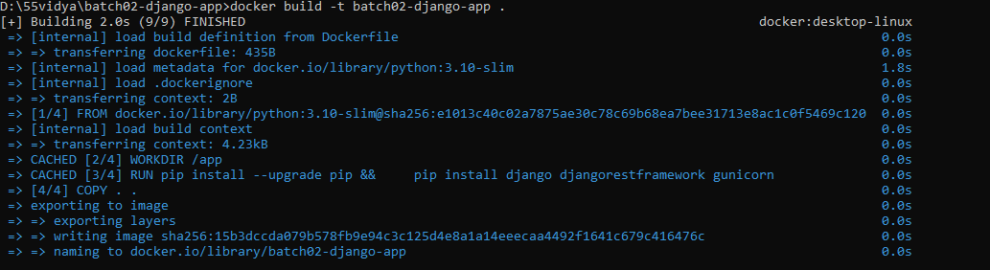Docker build -t batch02-django-app

**7.dokcer image:**

* It is used for to save the builded image in docker container
* It contains all the libraries ,dependencies and files to run a container

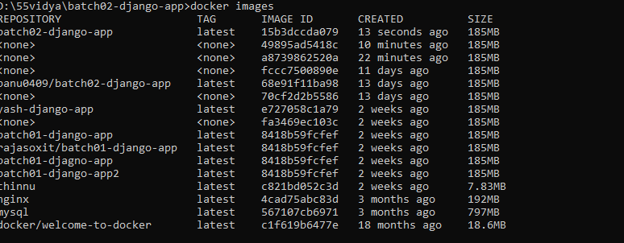

**8.docker run:**

* It is used to run a build image in docker file

**Example**

**Docker run -p 8000:8000 batch02-django**

**9.open browser:**

* **Open browser**
* **Type** [**https://local**](https://local)**host:8000/**

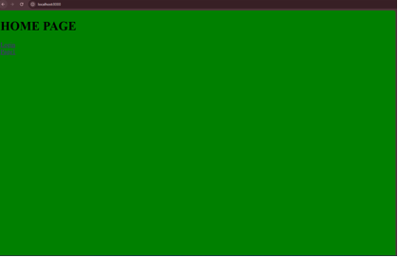

**10.vs code**

* **Open vs code**
* **New file🡪 new window**
* **Go to templates and select**
* **Home page🡪replace with kbn college**

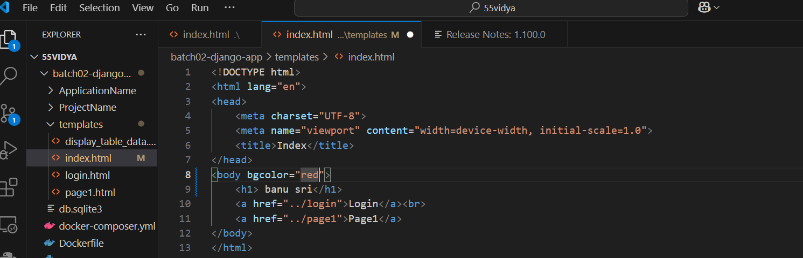

**11.docker build:**

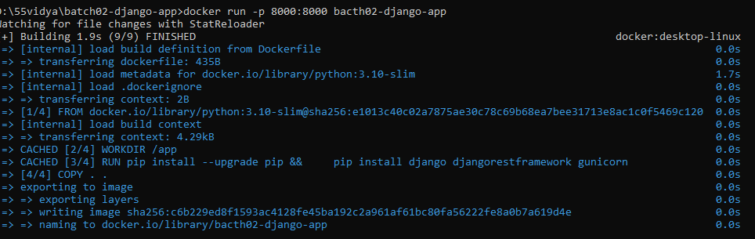**Save the file and create build**

**12.run the server:**

**13:again open browser:**

**14.login of docker hub:**

. create and login into docker hub

. create repository batch02-django-app

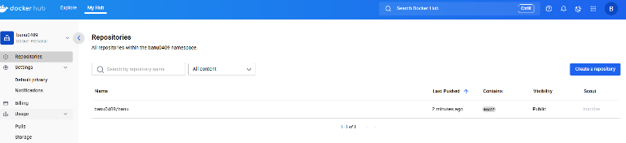

**. Repositories:**

**All repositories within the**

**55vidya/banu0409 name space**

**15.Dokcer tag:**

**16.Docker login:**

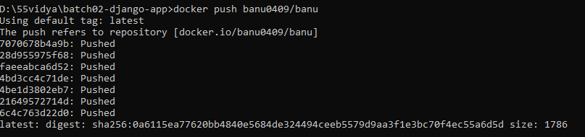**17. Docker push:**